<https://www.youtube.com/watch?v=gTK5rNhWJyA>

In this video will learn data cleaning, processing, analysis and dashboard creation in Excel. Complete data analytics project for data analyst in Excel.

Objective:

Amazon store wants to create an annual sales report for 2022. So that, Amazon can understand their customers and grow more sales in 2023.

Sample Data Analytics Questions:

1. Compare the sales and orders using a single chart.
2. Which month got the highest sales and orders?
3. Who purchased more men or women in 2022?
4. What are different order status in 2022.
5. List top 05 states contributing to the sales?
6. Relation between age and gender based on number of orders
7. Which channel is contributing to maximum sales?

Data Cleaning:

Check each column for null values and duplicate values,blanks

In the column of Gender we can see duplicate values for Men as M and for women as W so we need clean this column by replacing M with Men and W with Women.

We can see duplicate data in quantity data field

So, I am replacing One with 1 and Two with numeric 2.

Data Processing:

Now I am creating a age group(teenage, adult and Senior)

Formula

If(E2>=50,”Senior”,If(E2>=30,”Adult”,”Teenage”))

Now I should create a new column Month to extract month from the date column.

Data Analysis:

Now I am creating a pivot table

1. Compare the sales and orders using a single chart.

In the below chart two business problems are solved.

Sales means amount and order id (drag them into values)

1.Which month got the highest sales and orders?

2. Compare the sales and orders using a single chart.

1. Who purchased more men or women in 2022?

1. What are different order status in 2022.

1. List top 5 states contributing to the sales?

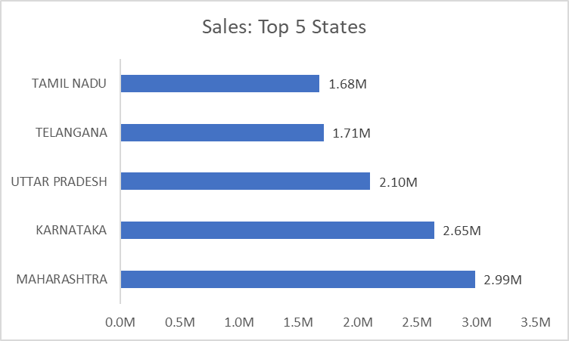

1. Relation between age and gender based on number of orders

|  |  |  |
| --- | --- | --- |
| **Count of Order ID** | **Column Labels** |  |
| **Row Labels** | **Men** | **Women** |
| Adult | 15.47% | 34.59% |
| Senior | 5.91% | 13.70% |
| Teenage | 9.20% | 21.13% |

We can see women does more orders then men

1. Which channel is contributing to maximum sales?

Ans:

Adding of slicers

Month, channel and category

Insights:

We can see that in the orders vs sales, march months has highest sales of 1.90M with the lowest sales in nov 1.60M

In Sales: men vs women: women are contributing more sales then men

Order status: So, most of the items are delivered with 92%

Top 5 states with more sales

Order vs Gender: We can see the primary contributors for orders are adults 34.59%  
Channels: People are buying products more from Amazon channel 35%

My sample insights.

Women are more likely to buy compared to men(~64%)

Maharastra,Karnataka, Uttar Pradesh are the top 3 states(~35%)

Adult age group(30-49 years) is max contributing ~50%)

Amazon,Flipkart and myntra channels are max contributing (~80%)

Final Conclusion of Real Canadian Store sales:

Target women customers of age group (30-49yrs) living in maharastra,Karnataka,Uttarpradesh by showing ads/offers/coupons available on Amazon,Flipkart and Myntra.